**Lab 1: The Apollo Missions**

**Edward Bertrand**

**March 9th, 2025**

1. **Introduction**

To send people to the moon, you need a basic understanding of the forces and gravitational potential that will impact the mission. A force is an interaction between two objects that results in an object accelerating, and during space travel, gravity is the dominant force that is acting on a spacecraft. Gravitational potential is a measure of energy a place has due to gravity. This tells us about the gravitational “strength” at a specific location. The larger the gravitational potential, the more energy required to move an object in that location. Calculating how this potential changes as distance from the Earth changes, allows us to predict the forces that will be impacting this mission. Using Python, I was able to calculate the gravitational potential at varying locations and visualized the results using different plotting methods, along with the force applied by the Earth-Moon system on the Apollo 11 command module. This report will present the required information to understand the forces that will present themselves in space, which will provide insight for acquiring funding for the Apollo missions.

1. **The gravitational potential of the Earth-Moon System**

The Earth and Moon are exerting gravitational forces on objects that are near them, and calculating the gravitational potential at varying locations allows us to predict the movement of objects, including their trajectories and required energy. Gravitational potential was calculated using the equation $Φ=-\frac{GM}{r}$, and a function was defined to calculate this at a given location (x,y) due to a mass M located at (xm,ym). To avoid dividing by zero for this function, the potential was set to NaN when the distance (r) approaches zero to prevent errors that could impact the plots. This function was then vectorized, which means that it operates on arrays that contain x and y coordinates, which represents a grid of evaluation points for the function. The total potential of the system was calculated by combining both bodies’ contributions. The results were plotted using a color-mesh plot with a logarithmic scale to better represent lower-potential regions, and a contour plot that displays equipotential lines. Figure 1 and Figure 2 confirm that the Earth is the dominant influence within the combined system, while showing the Moon’s increasing effect nearby.

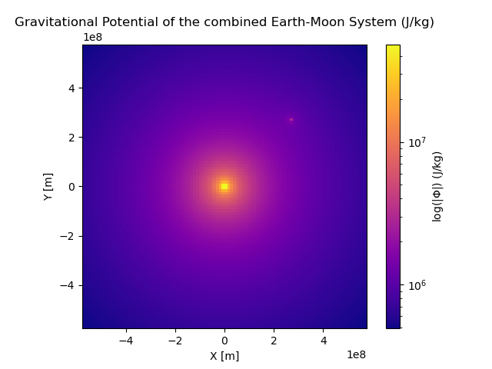Figure 1: 2D color-mesh plot of the gravitational potential of the Earth-Moon System.

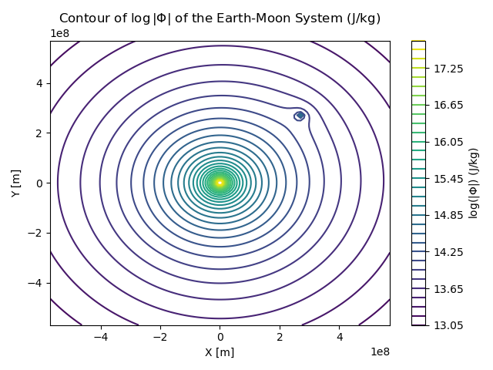

Figure 2: Contour of the logarithmic gravitational potential of the Earth-Moon System.

1. **The gravitational force of the Earth-Moon system**

The Earth and Moon exert gravitational forces on objects that are within their system. The Apollo 11 command module will experience these forces as the spacecraft is traveling. To accurately calculate these forces a function was defined that takes in the Earth and Moon’s mass, the position of the spacecraft, and it calculates the distance to both bodies. Using Newton’s law of gravitation, the function is able to calculate the magnitude of the gravitational forces, along with the direction of the forces from the angle between the spacecraft and both bodies. These forces that result from this are then separated into their x and y components, describing the direction the spacecraft travels in these conditions. This function needed to be vectorized so it would efficiently evaluate these forces of a grid of points in space, which allows us to calculate the forces at different locations quickly. These forces were then plotted using a stream plot as seen in Figure 3. This figure shows the strength and direction of the forces, and the color represents strength, with brighter colors corresponding to stronger forces. This plot helps us see and understand that the Earth’s gravitational force dominates the spacecraft’s trajectory in this system.

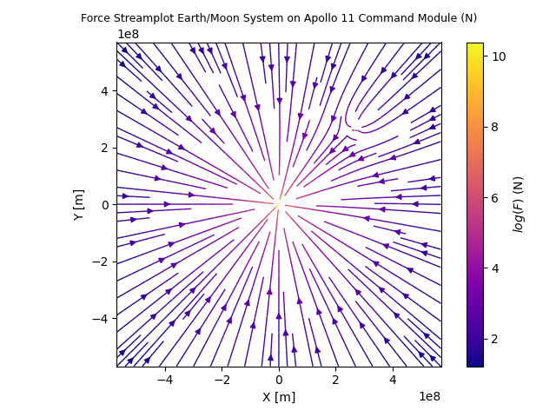

Figure 3: Force Streamplot of the Earth-Moon System on the Apollo 11 Command Module

**IV. Projected performance of the Saturn V Stage 1**

To project the performance of the Saturn V Stage 1, I had to use the Tsiolkovsky rocket equation: $Δv=v_{e}ln(\frac{m_{0}}{m(t)})$, where m0 is the initial “wet” mass, which consists of fuel + rocket parts + payload, $m(t)=m_{0}-\dot{mt}$, is the mass at time t, $\dot{m}$ is the fuel burn rate, ve is the fuel exhaust velocity, g is the gravitational acceleration, and it was ensured that Δv becomes zero once all fuel is burned. The wet mass, burn rate, exhaust velocity, and gravitational acceleration were assumed to be constant while calculating Δv. This equation provides the change in velocity of the rocket, which is required to calculate the altitude at burnout. A function was defined to calculate the burn time T using the equation $T=\frac{m_{0}-m_{f}}{\dot{m}}$, where mf is the final “dry mass” of the rocket when all of the fuel is burned. Since the rocket’s mass and velocity changes over time, I had to numerically integrate the change in velocity to determine the altitude at the end of the burn. This was done using the equation $h=\int_{0}^{T}{}Δv(t)dt$, integrating from t = 0 (launch) to t = T (burnout). The function quad was used to integrate because it efficiently handles the integration of time-dependent functions. The burn time and Δv functions were vectorized to apply these calculations to an array of values, which improves the code’s performance. Once these calculations were completed, it was found that the burn time for the first stage of the Saturn V rocket was 158 seconds, and that the altitude of the rocket at burnout was 74 km.

**V. Discussion and Future Work**

The approximations that were made include treating the Earth and Moon as point masses, constant fuel burn rate and exhaust velocity, neglecting air resistance, constant gravitational acceleration near the Earth’s surface, and constant mass for the spacecraft. Adjustments need to be made for these calculations to be more realistic, such as not using the Earth and Moon as point masses since their gravitational fields extend over large areas. Fuel burn rate and exhaust velocity need to change with time since they aren’t constant. Air resistance, especially at lower altitudes, must be included since it affects the spacecraft’s motion. Gravitational acceleration should decrease with altitude, along with the spacecraft’s mass decreasing as it consumes fuel. Also, the gravitational influence of the Sun should be considered near the Moon. These adjustments will provide more accurate predictions of the spacecraft’s trajectory and performance. When comparing our calculations to the test results, a burn time of 158 seconds for the first stage of Saturn V was predicted, which is 2 seconds shorter than the prototype’s 160 seconds. Then, the estimated altitude at the end of burn is 74 km, 4 km higher than the prototype’s 70 km. However, these calculations are not exact, because the burn time is likely an underestimate and the altitude is probably an overestimate. The neglected factors and simplified assumptions treat the rocket as it is more efficient than it is, which leads to shorter burn time and a higher altitude at burn. Adjusting these factors will lead to more accurate results.